CCT College Dublin

Assessment Cover Page

Module Title: | Data Analytical Tools (L7 Dip. in Data Analytics - Sept 2025 cohort)
Assessment Title: | CA2
Lecturer Name: | Kislay Raj
Student Full Name: | Rafael Da Rosa Barp
Student Number: | sba25079
Assessment Due Date: | 11 Apr. 2026
Date of Submission: | 09 Apr. 2026

Declaration

By submitting this assessment, I confirm that I have read the CCT policy on Academic Misconduct and understand the implications of submitting work that is not my own or does not appropriately reference material taken from a third party or other source. I declare it to be my own work and that all material from third parties has been appropriately referenced. I further confirm that this work has not previously been submitted for assessment by myself or someone else in CCT College Dublin or any other higher education institution.

Data Analytical Tools — CA2
Rafael Da Rosa Barp
CCT College Dublin — Diploma in Data Analytics, April 2026

1. Introduction
This report presents a data analytics pipeline applied to the Glass Identification Dataset from the UCI Machine Learning Repository (German, 1987). The dataset comprises 214 observations across 10 chemical composition features and one target variable representing six types of glass. Originally motivated by forensic criminology — where glass fragments at crime scenes serve as evidence — the analysis is applied here to support material classification for food packaging in an agricultural technology context.

The pipeline encompasses data preprocessing, descriptive and inferential statistical analysis, correlation analysis, and the development and comparison of two machine learning classification models: K-Nearest Neighbours (KNN) and Random Forest.

2. Data Analytics Software and Tools
All experimental work was conducted using Python 3 within Jupyter Notebook, leveraging Pandas, NumPy, Matplotlib, Seaborn, SciPy, and Scikit-learn. Tableau was used to develop an interactive dashboard with dynamic filtering by glass type, enabling visual exploration of chemical composition patterns by stakeholders. Python was selected for its extensive data science ecosystem and flexibility across the full analytics pipeline; Tableau for its capacity for interactive visual exploration beyond static plots.

3. Performing Data Analytics

3.1 Data Preprocessing
Upon loading the dataset (214 rows, 11 columns), the column 'id' was removed as it holds no analytical value. No missing values were found, one duplicated record was identified and removed. Outliers were detected across all variables using boxplots and the IQR method. Rather than removing them, they were retained: since outliers were present across all six glass type categories, they were deemed to represent genuine chemical variation inherent to each glass type, rather than noise or measurement errors. Removing them would risk discarding valid and informative observations.

3.2 Normality Testing — Shapiro-Wilk
The normality of each feature was assessed using the Shapiro-Wilk test. All nine chemical variables deviated significantly from a normal distribution (p < 0.05), guiding the subsequent choice of non-parametric statistical methods.

3.3 Homogeneity of Variance — Levene's Test
The three preconditions for One-Way ANOVA were evaluated: normality, homogeneity of variances, and independence. Independence was confirmed, but both normality and homogeneity (assessed via Levene's test) failed for the majority of variables. With only one of three conditions met, ANOVA was not applicable, the Kruskal-Wallis test was selected as the non-parametric alternative.

3.4 Inferential Analysis — Kruskal-Wallis Test
The Kruskal-Wallis H-test determines whether statistically significant differences exist between the medians of three or more independent groups without assuming normality. Applied to all nine features, results showed statistically significant differences across all variables (p < 0.05), leading to rejection of the null hypothesis in every case. This confirms that chemical composition varies meaningfully between glass types, providing strong justification for predictive modelling.

3.5 Correlation Analysis
A Pearson correlation matrix was visualised as a heatmap. Magnesium (mg) exhibited the strongest negative correlation with the target variable (r = -0.74), followed by aluminium (al) at 0.60, barium (ba) at 0.57, and sodium (na) at 0.51 — identified as the primary predictors. A strong correlation between refractive index (ri) and calcium (ca) at 0.81 indicated multicollinearity, a factor that could affect model stability.
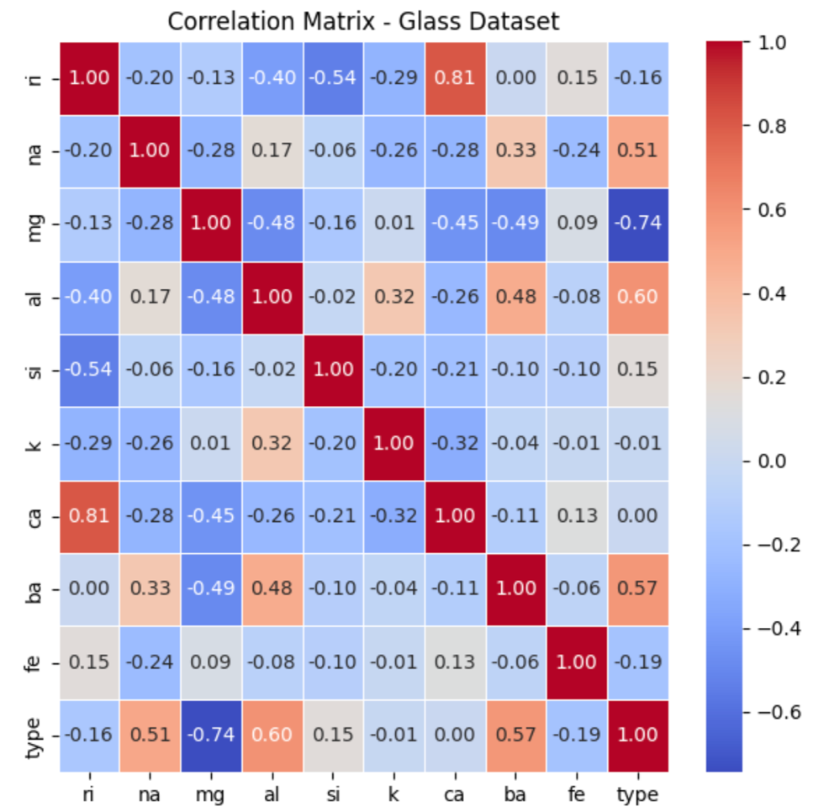
Fig. 1: Heatmap correlation between the classes and target

4. Visualising Findings and Results
In Python, boxplots and histograms were used during exploratory analysis to assess distributions and outliers. A correlation heatmap summarised inter-variable relationships. Confusion matrices for both models enabled a before-and-after comparison of classification performance.

In Tableau, an interactive dashboard was built comprising: a bar chart showing glass type distribution (revealing class imbalance); a box plot of magnesium by type; a scatter plot of mg versus al coloured by type, demonstrating class separability; and a multi-panel bar chart of average chemical composition per type. A global dynamic filter by glass type was applied, enabling all charts to update simultaneously.

5. Machine Learning Models

5.1 K-Nearest Neighbours (KNN)
The feature matrix was standardised using StandardScaler — mandatory for KNN due to its distance-based classification. An 80/20 stratified train/test split was applied to ensure proportional class representation. Error rates were computed for K values from 1 to 30; K=3 was selected as it matched K=1 performance while offering greater generalisation and lower overfitting risk. The KNN model achieved 77% accuracy, performing well on majority classes but struggling with minority classes (types 3, 5, and 6), reflecting the dataset's class imbalance.
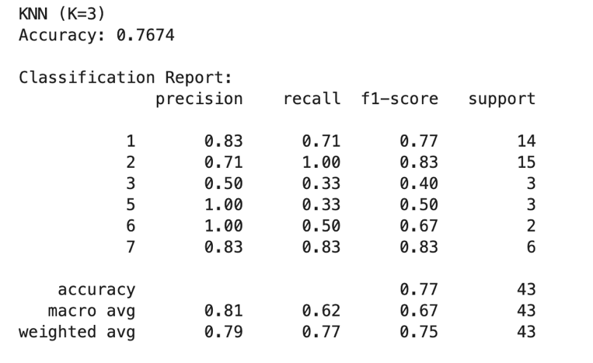
Fig. 2: KNN Classification Report.
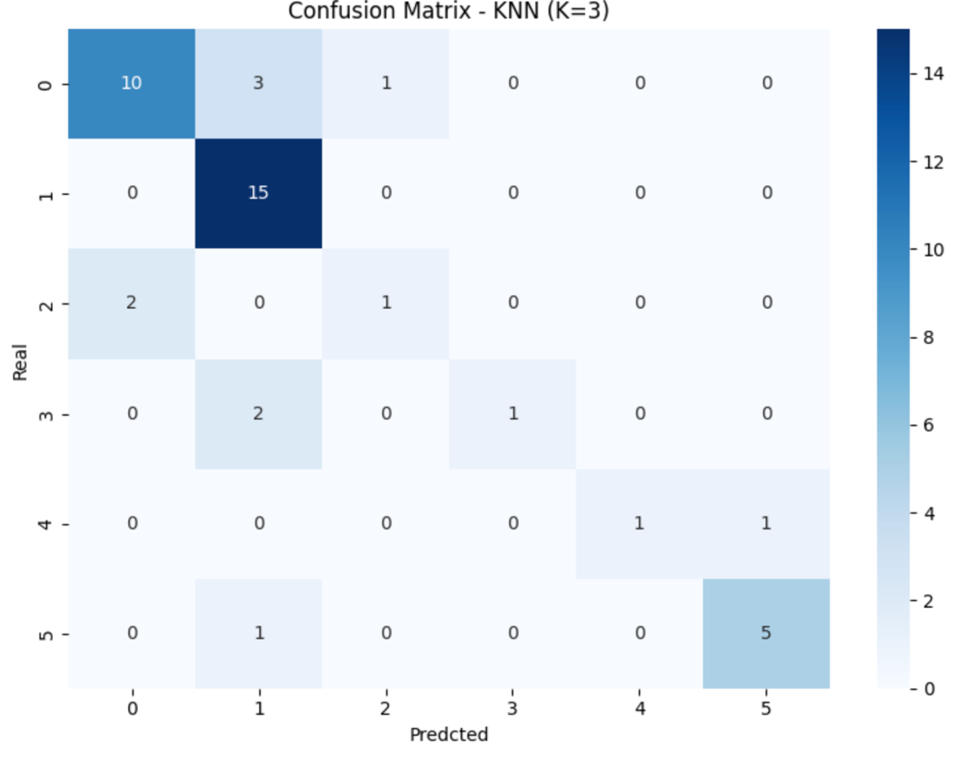
Fig. 3: KNN Confusion Matrix.

5.2 Random Forest
A Random Forest classifier with 100 trees was trained. This ensemble method was chosen for its robustness to class imbalance, capacity to capture non-linear relationships, and interpretability via feature importance. The model achieved 84% accuracy, outperforming KNN across all metrics, with perfect classification of glass type 7 (F1 = 1.00) and marked improvement on minority classes.
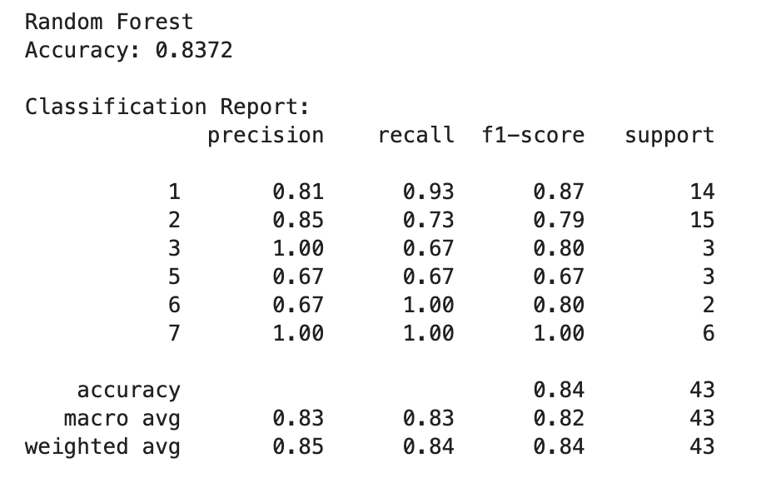
Fig. 4: Random Forest Classification Report.
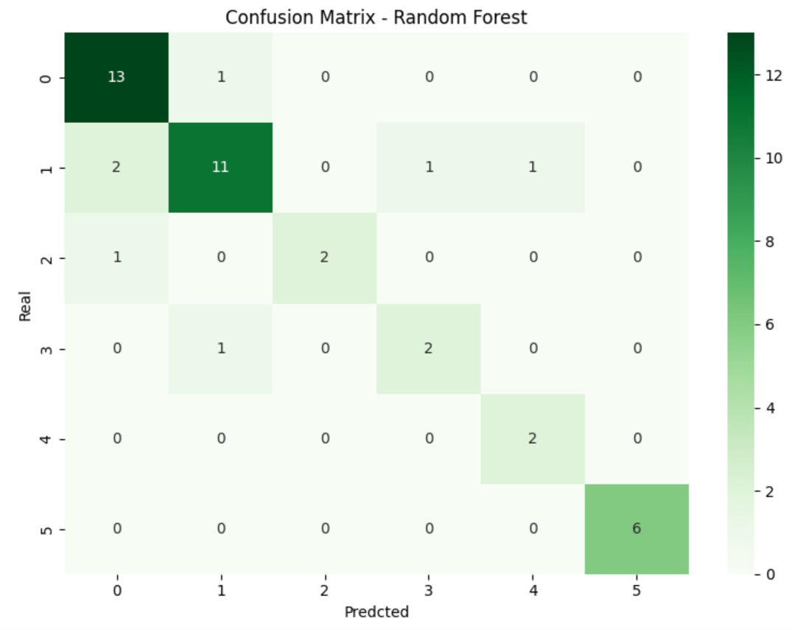
Fig. 5: Random Forest Confusion Matrix.

5.3 Model Comparison — Cross-Validation
10-fold cross-validation confirmed Random Forest superiority: 73.7% mean accuracy vs. 67.1% for KNN. KNN showed lower standard deviation (0.087 vs. 0.129), indicating greater consistency across folds. Random Forest was selected as the preferred model.

Metric | KNN (K=3) | Random Forest
Train/Test Accuracy | 77% | 84%
CV Mean Accuracy | 67.1% | 73.7%
CV Std Deviation | 0.087 | 0.129
Macro Avg F1-Score | 0.67 | 0.82
Weighted Avg F1-Score | 0.75 | 0.84

5.4 Feature Importance
Feature importance scores from Random Forest aligned with correlation findings: mg (16.2%), al (16.0%), ri (13.6%), and ca (12.5%) were the top predictors; fe ranked lowest (4.4%). This convergence between statistical analysis and model outputs reinforces the robustness of the conclusions.
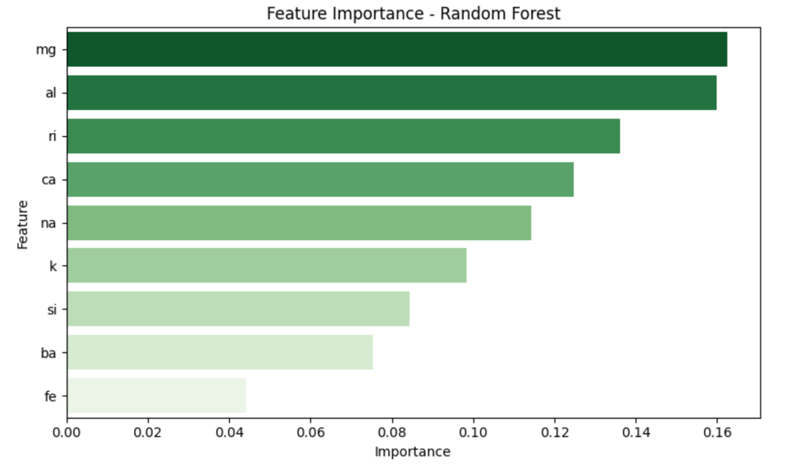
Fig. 6: Feature Importance.

6. Recommendations, Challenges and Solutions

6.1 Recommendations
Random Forest is recommended as the primary classification tool. Data collection efforts should prioritise mg, al, ba, and na, as they demonstrated the greatest predictive power. Class imbalance should be addressed through oversampling techniques such as SMOTE, which could significantly improve performance on types 3, 5, and 6. The multicollinearity between ri and ca warrants attention, Principal Component Analysis (PCA) could be explored to mitigate its effect on model stability.

6.2 Challenges and Solutions
Three main challenges were encountered. First, non-normality and heteroscedasticity precluded ANOVA, requiring adoption of Kruskal-Wallis through systematic evaluation of its preconditions. Second, class imbalance impacted both models; stratified splitting yielded a 7% accuracy improvement in KNN (70% to 77%), though the structural imbalance remains a dataset limitation. Third, K=1 minimised KNN error rate but was rejected in favour of K=3 to reduce overfitting risk, illustrating the importance of balancing performance with generalisation.

7. Conclusion
This report applied a rigorous data analytics pipeline to the Glass Identification Dataset. Through preprocessing, Shapiro-Wilk and Levene testing, Kruskal-Wallis inferential analysis, correlation analysis, and KNN and Random Forest modelling, a comprehensive understanding was achieved. Random Forest emerged as the preferred classifier with 84% accuracy and macro F1 of 0.82, confirmed by cross-validation. Chemical composition — particularly mg, al, ba, and na — is a reliable basis for glass type classification, with applications in forensic science and food packaging material testing.

References
German, B. (1987) Glass Identification [Dataset]. UCI Machine Learning Repository. Available at: https://doi.org/10.24432/C5WW2P (Accessed: 8 April 2026).

SciPy (2024) scipy.stats.kruskal. Available at: https://docs.scipy.org/doc/scipy/reference/generated/scipy.stats.kruskal.html (Accessed: 6 April 2026).
Bobbitt, Z. (2020) 'How to Perform a Kruskal-Wallis Test in Python', Statology. Available at: https://www.statology.org/kruskal-wallis-test-python/ (Accessed: 6 April 2026).

Scikit-learn (2024) sklearn.neighbors.KNeighborsClassifier. Available at: https://scikit-learn.org/stable/modules/generated/sklearn.neighbors.KNeighborsClassifier.html (Accessed: 7 April 2026).

Scikit-learn (2024) sklearn.ensemble.RandomForestClassifier. Available at: https://scikit-learn.org/stable/modules/generated/sklearn.ensemble.RandomForestClassifier.html (Accessed: 7 April 2026).

Artificial Intelligence Usage Declaration
In the completion of this assessment, generative AI tools were used exclusively for the following permitted activities: brainstorming analytical approaches, refining research questions, identifying appropriate statistical methods, and checking grammar and style of the written report. All code, analysis, interpretation of results, and conclusions presented in this work are the student's own. No AI tool was used to generate code, write assignment content, or produce any section of this report in full.

